**Task 1.1 : Create Resource Groups based on different project environments(e.g., Development, Testing, Production). Explain the organizational benefits of using Resource Groups.**

Created three resource groups : Development, Testing, Production

I have created two virtual machines dev1 and dev2, containing Windows 11

**Task 1.2: Explore and document the purpose and usage of Availability Zones and Availability sets in ensuring application reliability, without creating VMs.**

Created a virtual machine dev1 under the resource Development

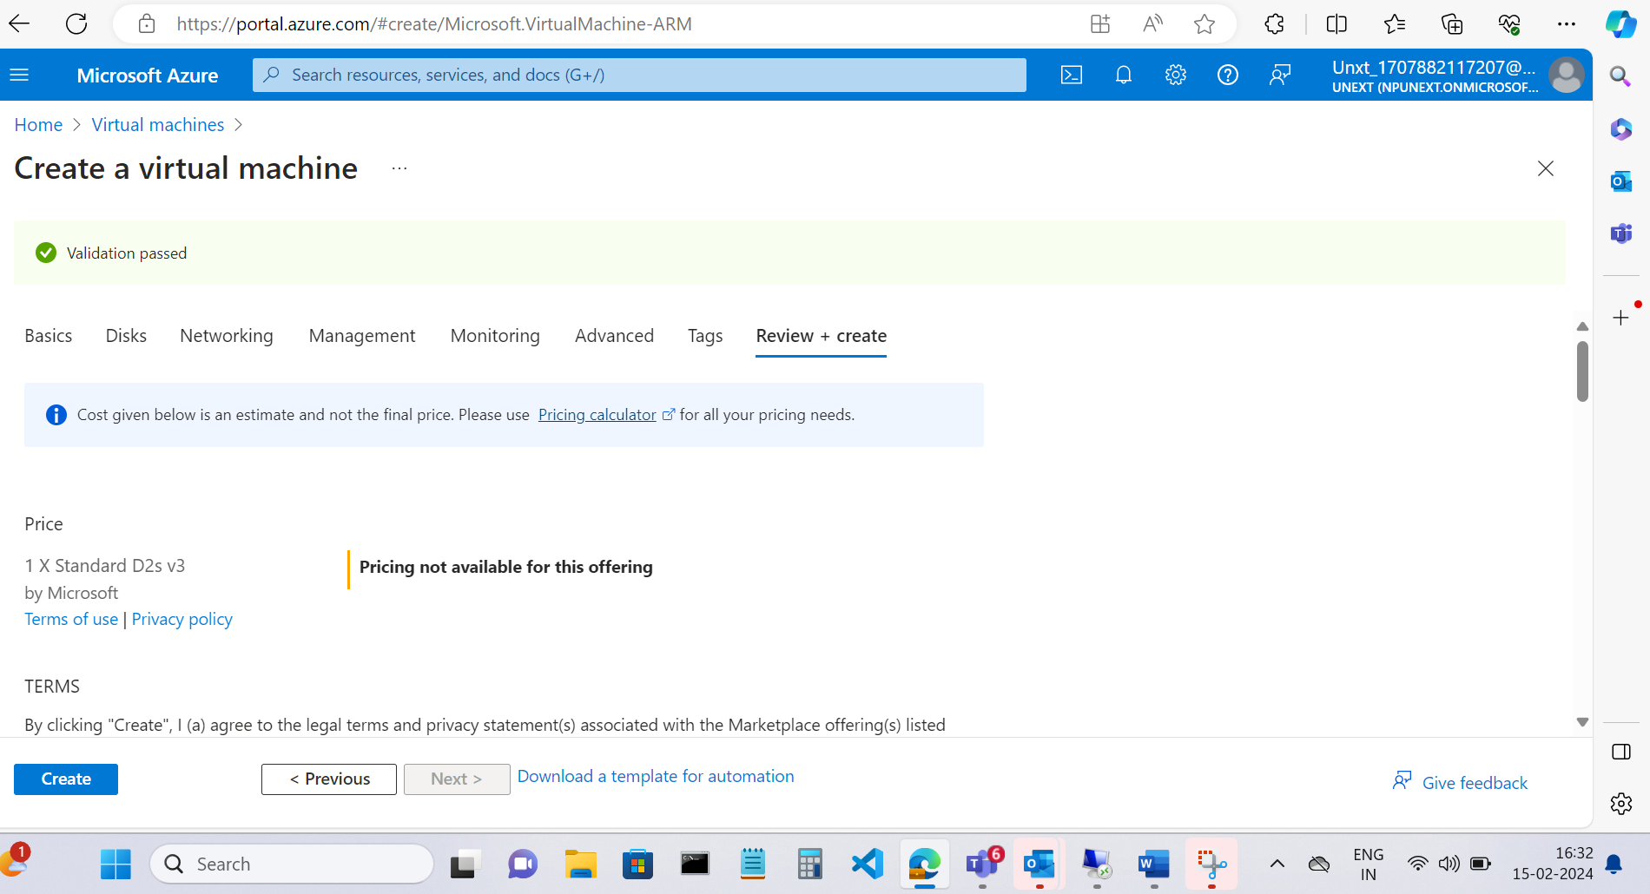

Created another Virtual Machine dev2

Set of all the virtual machine created :

